10202 Computer Graphics II Illustrator
23Aug | Classroom Management  Control Panel > View Hidden File Extensions  Map Network Drives  WatchoChange Security Permissions on your Programming Work Folder On your Desktop  - Navigate to C:\to the desktop  - Once in your folder right click inside the folder and arrow down to “New” and click then click on “Folder”.  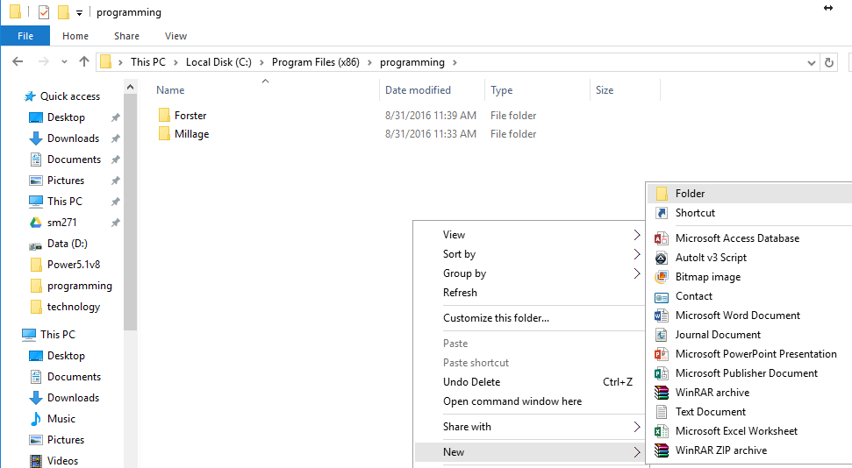  This will create a new folder, name the folder whatever you would like  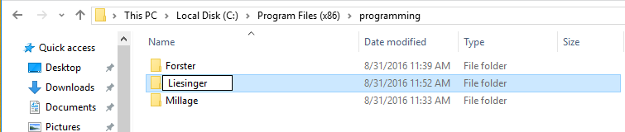  Now right click your newly named folder and arrow down to “Properties”  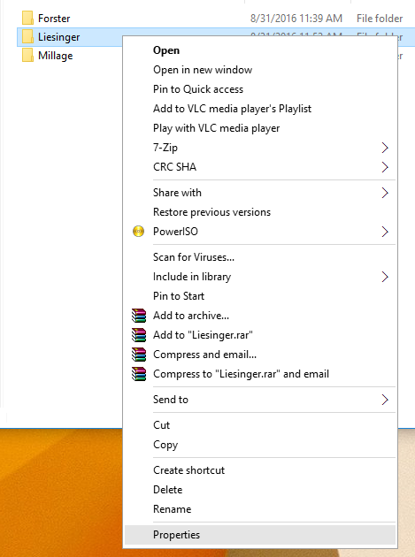  From the Properties window click on the “Security” tab, and click “Edit”  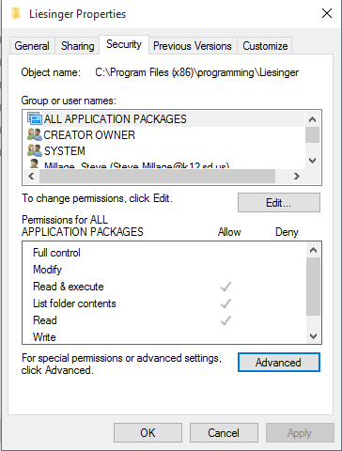  From the Permissions windows find your name, single click it, and then check the “Full Control” check box with-in the Permissions section. Click OK  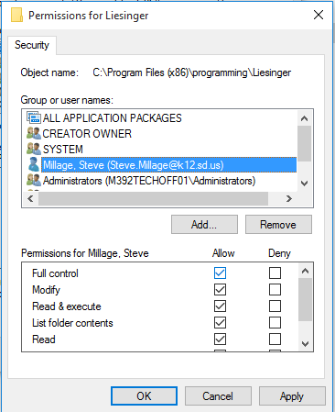  Back at the Properties window, click the “Advanced” option  With-in the Advanced Security settings, click the “Disable inheritance” option  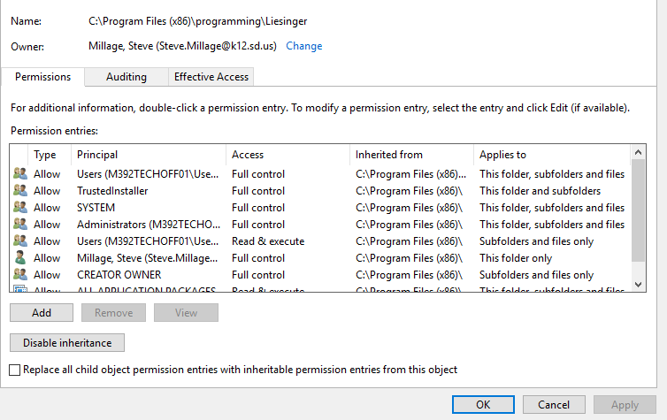  You will now be prompted with an option on how you want to inherit the permissions. Chose the option “Convert inherited permissions into explicit permissions on this object.”  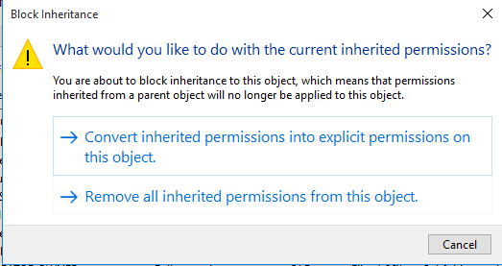  Back to the Advanced Security Settings window, in the permissions entries section, there is a column called “Principal”. With-in the column single clock the “Users” and then click “remove”, then click OK, and OK again with-in the Properties window.  Students will now log out, switch computers, try to delete their neighbor’s folder to troubleshoot security.
27Aug | Welcome  001HowToUseThisTutorial  002GettingStarted  003VectorVsRaster  Basic User Interface  004Overview  005Preferences  006Artboard  DakBoardInGym  RecordClips  DownloadClips  Size&RenderClips  StoreClips
29Aug | Basic User Interface (Cont.)  007MenuBar  008ControlPanel  009Panels  010ToolsPanel  011Workspace  DakBoardInGym  UploadClipsInAE  ReplaceClipsVideo  EditClipsSizeShape&Text  RenderClips
3Sep | WorkingWithDocuments  012PrintWorkflow  013 ElectronicWorkFlow  014RulersGuides&SmartGuides  015Grids&Snaps  016PerspectiveGrids  DakBoardInGym  RenderClipsInAE  ConvertClipsVideo  StoreClipsOnFlashDrive  PlaceClipsOnDakBaord
5Sep | WorkingWithDocuments(Continued)  017Preview&OutlineModes  018Navigating  019Viewing  020Exercise1Apart1  021Exercise1Apart2  022Exercise1B  023Exercise1C
10Sep | WorkingWithSelections(Begin)  024SelectionTool  025DirectSelectionTool  026Lasso&MagicWandTools  027Grouping&Isolation  028Scaling&Rotating  029Exercise2
12Sep | Flood
13Sep  Friday  7Pd Day | Flood
17Sep | WorkingWithShapes(Begin)  030ShapeTools1  031ShapeTools2  032EditCommands  033Fills  034Strokes  035AppearancePanel  036Exercise3
19Sep | WorkingWithPaths(Begin)  037Open&ClosedPaths  038LineTools  039PencilTools  040PaintTools  041PenToolStraightLines  042PenToolConvertLines
20Sep | Homecoming Activities
24Sep | WorkingWithPaths(Continued)  043CurvatureTool  044Erase&CutTools  045SliceTools  046PathOperations1  047PathOperations2  048StrokePanel1  049StrokePanel2
26Sep | WorkingWithPaths(Continued)  050Exercise4A  051Exercise4B  052Exercise4C
27Sep Friday 7pds | WorkingWithTransformations(Begin)  053ScaleTool  054Sheadr&ReshapeTools  055Rotate&ReflectTools  056FreeTransformTool  057DistortionTools1  058DistortionTools2
1Oct | WorkingWithTransformations(Continued)  059GroupLock&Hide  060Step&Repeat  061AlignObjects  062DistributeObjects  063PathfinderObjects  064ShapebuilderTools1  065ShapeBuilderTools2
3OCT | WorkingWithTransformations(Continued)  066Exercise 5A Part1  067Exercise 5A Part2  068Exercise 5B Part1  069Exercise 5B Part2
4Oct Friday 7pd day | WorkingWithLayers(Begin)  070StackingOrder  071LayersPanel  072Creating&Editing  073hDuplicating&Rearranging  074Locating&Deleting  075Exercise6
8Oct | WorkingWithType(Begin)  076TypePreferences  077Point&Area  078TypeToools  079CharacterPanel1  080CharacterPanel2  081ParagraphPanel
10Oct | WorkingWithType(Begin)  082ThreadingType  083AreaTypeTools  084TypeOnPath1  085TypeOnPath2  086TouchTypeTool  087OutlineType  088TypeKit
11Oct  Friday 7pds | WorkingWithType(Begin)  089Exercise7A  090Exercise7B Part1  091Exercise7B Part2
15Oct | WorkingWithColor(Begin)  092PrintColor  093ElectronicColor  094SwatchesPanelPart1  095SwatchesPanelPart2  096ColorGuide  097Creating&Editing  098Tints&Opacities  099Gradients  100Meshes&Blends
17Oct | WorkingWithColor(Type)  101Exercise8Part1  102Exercise8part2  FinalizingAProject(Begin)  103PrintingPart1  104PrintingPart2  105SavingForPrint  106SavingForElectronic  107SavingTemplates  108SavingPDF  109ExportingToPhotoshop  110Packaging  111Exercise9
18Oct | 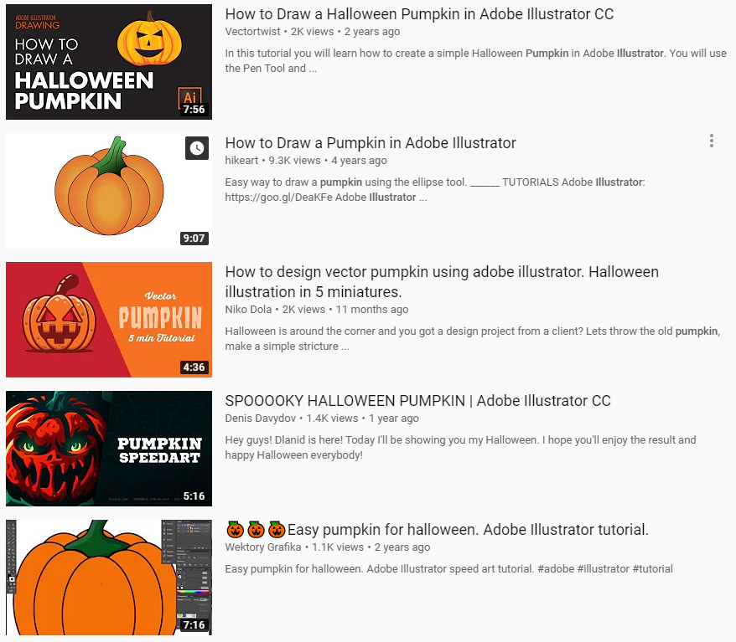  Now that you have completed the entire course, you are going to put all the fundamentals together to create a design graphic for future animation.  Learning Target: Create Organic Shapes using a computer graphic software.  Standard GD3 Graphic Design  Webb Level 4 Extended Thinking  Sub Indicator 3.2 Implement graphic design software  Pick a Pumpkin: Go to Youtube and pick a pumpkin to practice on.
22Oct | Now that you have completed the entire course, you are going to put all the fundamentals together to create a design graphic for future animation.  Learning Target: Create Organic Shapes using a computer graphic software.  Standard GD3 Graphic Design  Webb Level 4 Extended Thinking  Sub Indicator 3.2 Implement graphic design software  Pick a Pumpkin: Go to Youtube and pick a pumpkin to practice on.
24Oct | Now that you have completed the entire course, you are going to put all the fundamentals together to create a design graphic for future animation.  Learning Target: Create Organic Shapes using a computer graphic software.  Standard GD3 Graphic Design  Webb Level 4 Extended Thinking  Sub Indicator 3.2 Implement graphic design software  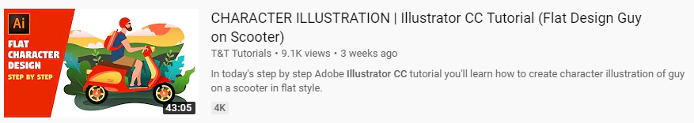  Students will click and complete: https://www.youtube.com/results?search_query=Illustrator+CC
25Oct Friday 7pds | Continued:  Now that you have completed the entire course, you are going to put all the fundamentals together to create a design graphic for future animation.  Learning Target: Create Organic Shapes using a computer graphic software.  Standard GD3 Graphic Design  Webb Level 4 Extended Thinking  Sub Indicator 3.2 Implement graphic design software  Students will click and complete: https://www.youtube.com/results?search_query=Illustrator+CC
29Oct | Now that you have completed the entire course, you are going to put all the fundamentals together to create a design graphic for future animation.  Learning Target: Create Organic Shapes using a computer graphic software.  Standard GD3 Graphic Design  Webb Level 4 Extended Thinking  Sub Indicator 3.2 Implement graphic design software  Students will click and complete: https://www.youtube.com/results?search_query=Illustrator+CC
31Oct | Now that you have completed the entire course, you are going to put all the fundamentals together to create a design graphic for future animation.  Learning Target: Create Organic Shapes using a computer graphic software.  Standard GD3 Graphic Design  Webb Level 4 Extended Thinking  Sub Indicator 3.2 Implement graphic design software  Students will click and complete: https://www.youtube.com/results?search_query=Illustrator+CC
1Nov | Learning Target: Create Organic Shapes using a computer graphic software.  Standard GD3 Graphic Design  Webb Level 4 Extended Thinking  Sub Indicator 3.2 Implement graphic design software  Students will click and complete: https://www.youtube.com/watch?v=xMjI6xc7jdM  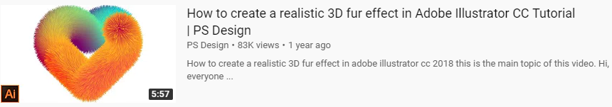
5Nov | Learning Target: Glass Planet Vector Illustration – Adobe Illustrator CC.  Standard GD3 Create Graphic Designs  Webb Level 4 Extended Thinking  Sub Indicator 4.3 Create Graphic Design Products  Students will click and complete: https://www.youtube.com/watch?v=Z2SNeH9v-Ug  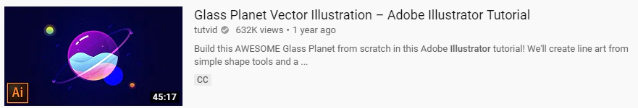
7Nov | Learning Target: Glass Planet Vector Illustration – Adobe Illustrator CC.  Standard GD3 Create Graphic Designs  Webb Level 4 Extended Thinking  Sub Indicator 4.3 Create Graphic Design Products  Students will click and complete: https://www.youtube.com/watch?v=Z2SNeH9v-Ug
12Nov | Learning Target: Glass Planet Vector Illustration – Adobe Illustrator CC.  Standard GD3 Create Graphic Designs  Webb Level 4 Extended Thinking  Sub Indicator 4.3 Create Graphic Design Products  Students will click and complete: https://www.youtube.com/watch?v=Z2SNeH9v-Ug
14Nov | Learning Target: Glass Planet Vector Illustration – Adobe Illustrator CC.  Standard GD3 Create Graphic Designs  Webb Level 4 Extended Thinking  Sub Indicator 4.3 Create Graphic Design Products  Students will click and complete: https://www.youtube.com/watch?v=Z2SNeH9v-Ug
15Nov | Learning Target: Glass Planet Vector Illustration – Adobe Illustrator CC.  Standard GD3 Create Graphic Designs  Webb Level 4 Extended Thinking  Sub Indicator 4.3 Create Graphic Design Products  Students will click and complete: https://www.youtube.com/watch?v=Z2SNeH9v-Ug
19Nov | Learning Target: Business Logo – Adobe Illustrator CC.  Standard GD3 Create Graphic Designs  Webb Level 4 Extended Thinking  Sub Indicator 2.2 Differentiate 2D and 3D Graphic Design Concepts  Students will click and complete: https://www.youtube.com/watch?v=YycxaAK2MZ4  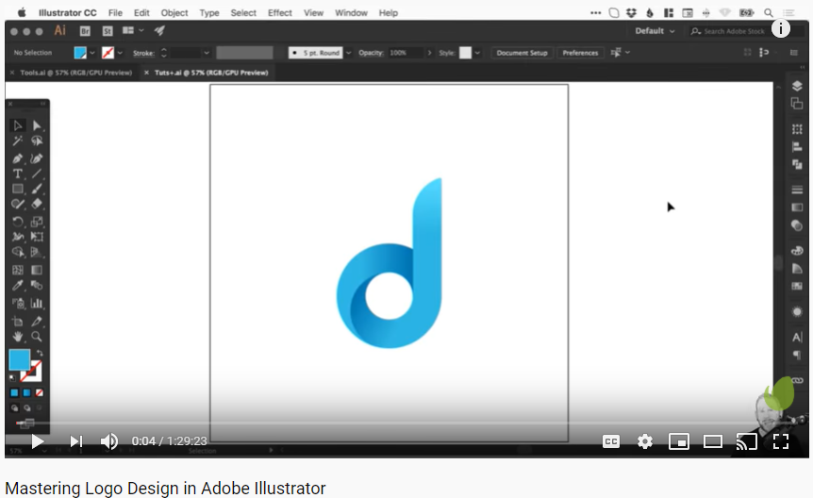
21Nov | Learning Target: Learn to Draw Anything – Adobe Illustrator CC.  Standard GD3 Create Graphic Designs  Webb Level 4 Extended Thinking  Sub Indicator 4.3 Create Graphic Design Products  Students will click and complete: https://www.youtube.com/watch?v=RbbQl2sU-ag  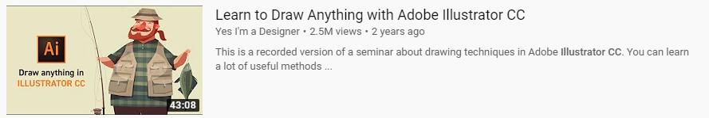
22Nov | Learning Target: Learn to Draw Anything – Adobe Illustrator CC.  Standard GD3 Create Graphic Designs  Webb Level 4 Extended Thinking  Sub Indicator 4.3 Create Graphic Design Products  https://www.youtube.com/watch?v=AHK0mtHRSc0  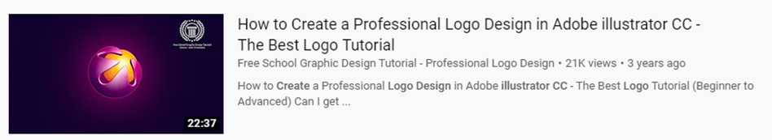
26Nov | Learning Target: Learn to Draw Anything – Adobe Illustrator CC.  Standard GD3 Create Graphic Designs  Webb Level 4 Extended Thinking  Sub Indicator 4.3 Create Graphic Design Products  https://www.youtube.com/watch?v=AHK0mtHRSc0  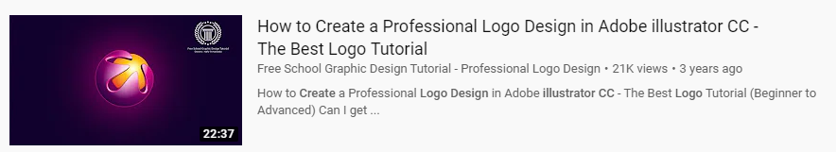
3Dec | Learning Target: Learn to Draw Anything – Adobe Illustrator CC.  Standard GD3 Create Graphic Designs  Webb Level 4 Extended Thinking  Sub Indicator 4.3 Create Graphic Design Products  https://www.youtube.com/watch?v=AHK0mtHRSc0
5Dec | Learning Target: Learn to Draw Anything – Adobe Illustrator CC.  Standard GD3 Create Graphic Designs  Webb Level 4 Extended Thinking  Sub Indicator 4.3 Create Graphic Design Products  https://www.youtube.com/watch?v=CVLsc6KaLkg  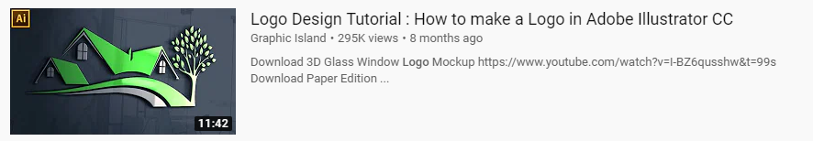
6Dec | Learning Target: Learn to Draw Anything – Adobe Illustrator CC.  Standard GD3 Create Graphic Designs  Webb Level 4 Extended Thinking  Sub Indicator 4.3 Create Graphic Design Products  https://www.youtube.com/watch?v=CVLsc6KaLkg
10Dec | Learning Target: Learn to Draw Anything – Adobe Illustrator CC.  Standard GD3 Create Graphic Designs  Webb Level 4 Extended Thinking  Sub Indicator 4.3 Create Graphic Design Products  https://www.youtube.com/watch?v=XFT56R2xmic  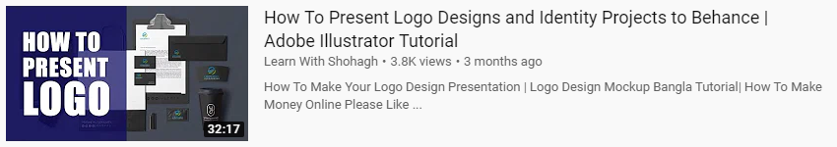
12Dec | Learning Target: Learn to Draw Anything – Adobe Illustrator CC.  Standard GD3 Create Graphic Designs  Webb Level 4 Extended Thinking  Sub Indicator 4.3 Create Graphic Design Products  https://www.youtube.com/watch?v=XFT56R2xmic
13Dec | Review Written Exam
17Dec | Complete Final Exam
20Dec | Peer Grading
Project1: TutankamonExhibit
102ProjectOverview
103ArtCleanUp
104ImportArt
105TracingTheArtPart1
106TracingTheArtPart2
107ClippingMask
108ApplyingColors
109OpacityMask
110BlendModeHighlights, AddingEffects, Finish Poster
Project2: Excalibur
111ProjectOverview
112ConstructTheSwordPart1
113ConstructTheSwordPart2
114ConstructTheSwordPart3
115ConstructTheSwordPart4
116ConstructTheSwordPart4
117ConstructTheSwordPart4
118ConstructTheSwordPart5
119Detail1
120Detail2Project3: Coffee Cup
121ProjectOverview
122CoffeePot1
123CoffeePot2
124CoffeePot3
125CoffeePot4
126CoffeePot5
127CoffeePot6
128CoffeePot7Finished
Project4: OrbLogo
129MappingInvisibleGeometry
130MappingStepByStep
+Project5: Impossible Triangle
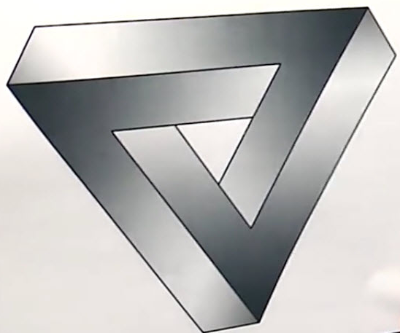
131Tracing the Impossible Triangle

Project6: Impossible Cubes
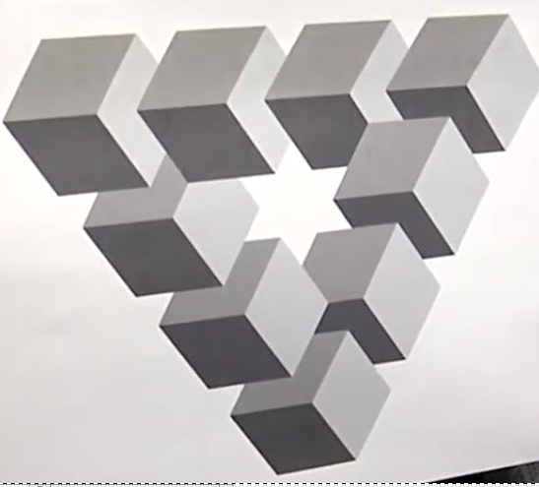
132Tracing the Impossible Cubes

Project7: Infinite Ribbon
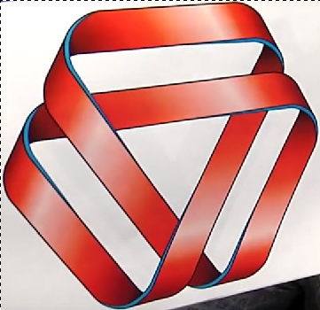
133Tracing the Infinite Ribbon

Project8: Bulldog Logo(Multiple Logo’s)
134FlashAnimation(AnimateSchool Logos for DaktronicsBoard)

Here is the drop box link for every school in South Dakota’s logo: https://www.dropbox.com/sh/nudc6af3u4op6uf/AAB4OedigReQF_qmr-fhTArta?dl=0
You have permission to use these logos. You will need to “Download” these to your computer before beginning to work on them.

Project9: FlashAnimation
135FlashAnimation (Animate School Logos for Daktronics Board)
Project10: FlashIntegration
136FlashIntegration (Animate School Logos for Daktronics Board)
Project11a: FinalProject1
137FinalProject1 (Animate School Logos for Daktronics Board)
Project11b: FinalProject1
138FinalProject1(Animate School Logos for Daktronics Board)
Project11c: FinalProject1
139FinalProject1(Animate School Logos for Daktronics Board)
Project12: Fat Cat
140FatCatLongShadow
Project12: Fat Cat
141FatCatLongShadow
Project12: Fat Cat
142FatCatLongShadow
Project13: String Of Pearls
143StringOfPearls
Project13: String Of Pearls
144StringOfPearls
Project14: MHS Logo
145(Animate School Logos for Daktronics Board)
Project14: MHS Logo
146(Animate School Logos for Daktronics Board)
Project15: Glass Marble
147GlassMarble
Project15: Glass Marble
148Glassmarble
Project11a, 11b, 11c: FinalProject1
149FinalProject1(Animate School Logos for Daktronics Board)
Final Exam: Written
150
: Animate School Logos
LearningTarget
Students: Will create, trace, or copy a school logo in Photoshop, Illustrator, or Flash
Will create, trace, or copy a background in Photoshop, Illustrator, or Flash
Will animate assigned school logos in Flash or AfterEffects.
Will animate assigned sport backgrounds in Flash or After Effects.
Will place final product to the Daktronics Board first computer
Will place Buttons on the Daktronics Board second computer

Backgrounds to be Animated: Volleyball, Basketball, Wrestling, Gymnastics, Powerlifting,
Madison All Sports (Generic).
School Logos to be Animated:

Dak XII Conference (Madison, Beresford, Canton, Dakota Valley, Dell Rapids Public, ElkPoint-Jefferson, Lennox, Sioux Falls Christian, Tea Area, Tri-Valley, Vermillion, West Central)

Misc: Alcester-Hudson, Arlington, Baltic, Bridgewater-Emery, Castlewood, Chester, Canistota, Chamberlain, Colman-Egan, Dell Rapids St. Marys, DeSmet, Deubrook, Estelline, Elkton-Lake Benton, Ethan, Flandreau, Flandreau Indians, Garretson, Groton, Gregory, Hanson, Hills-Beaver Creek, Howard, Lake Preston, Lake Andes-Dakota Christian, McCook Central-Montrose, Mitchell Christian, Milbank, O-Gorman, Oldham-Ramona-Rutland, Pipestone, Redfield-Doland, Scotland, SDHSAA Logo, Sioux Falls Lincoln, Sioux Valley, Sanborn Central-Woonsocket, St.Francis, Waverly-South Shore, Wolsey-Wessington

